Web Scraping from Website –

Project Report

Author:Brindha Devi
Project Type: Individual Project
Git Repo Link: https://github.com/brindhasp/CodeAlpha_Web-Scraping

EXECUTIVE SUMMARY:
The Web Scraping System is a Python-based application developed to extract useful data from public websites automatically. This project uses Python libraries such as Requests, BeautifulSoup, and Pandas to collect quotes, authors, and tags from a website and convert them into a structured dataset. The extracted data is cleaned, organized, and stored in CSV format for further analysis and visualization. This project demonstrates how web scraping helps in transforming unstructured web content into meaningful datasets for data analytics and decision-making. It highlights the importance of automation in data collection and its applications in real-world data-driven environments.

PROJECT OVERVIEW:

Objective:

To design and develop a Python-based web scraping system that extracts quotes, authors, and tags from a public website and stores them in a structured dataset for analysis.

Scope:

- Extract data from a public website using Python
- Parse HTML content using BeautifulSoup
- Collect quotes, author names, and tags
- Convert extracted data into structured dataset
- Store dataset in CSV format
- Prepare data for analytics and visualization

Key Features
1. Automated Data Extraction
The system automatically collects quotes, authors, and tags from the website without manual intervention.
2. HTML Parsing and Processing
BeautifulSoup is used to analyze webpage structure and extract required information accurately.
3. Structured Dataset Creation
Extracted data is organized into tabular format using Pandas for easy handling.
4. CSV Export Functionality
The dataset is stored in CSV format which can be used for further analysis and visualization.
5. Efficient and Lightweight System
The program is simple, fast, and requires minimal system resources.
6. Scalable Architecture
The system can be extended to scrape multiple pages or different websites.
7. Data Analytics Ready
The generated dataset can be used for EDA, visualization, and machine learning tasks.

TECHNICAL IMPLEMENTATION:

Technology Stack:
- Programming Language: Python
- Web Scraping Libraries: Requests, BeautifulSoup
- Data Handling: Pandas
- Development Tools: VS Code / Jupyter Notebook
- Data Source: https://quotes.toscrape.com

Performance Metrics:

- Data extraction accuracy
- Successful parsing rate
- Dataset completeness
- Processing time
- Data storage efficiency

SOURCE CODE IMPLEMENTATION (Screenshot)

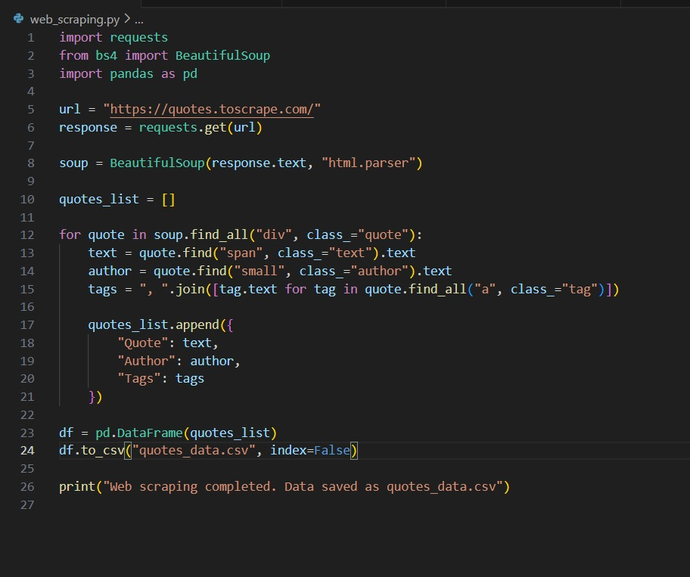

Extracted Job Result In Excel:

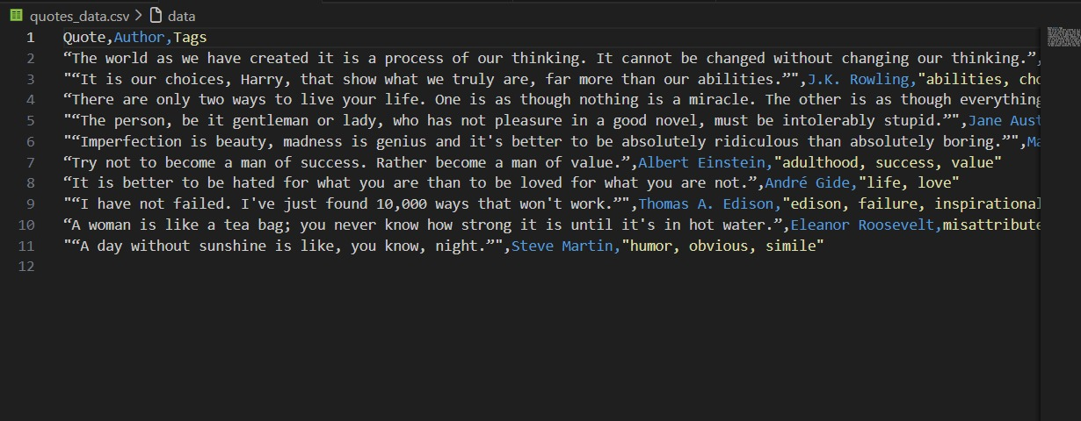
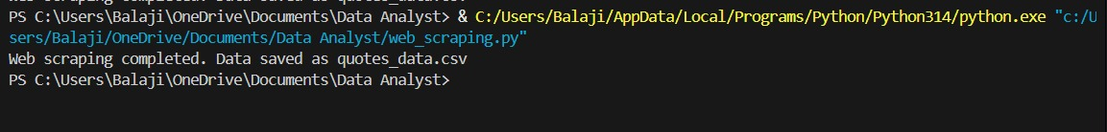

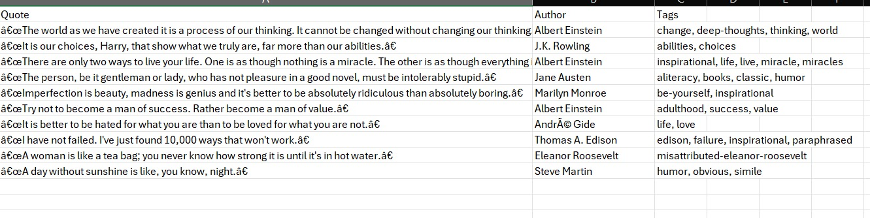

CONSTRAINTS:

Resource Constraints:
- Internet connection required
- Website structure changes may affect scraping
- Limited data from single page
- Dynamic websites require advanced scraping methods
- Data cleaning required for large datasets

PROJECT IMPACT AND VALUE:
Immediate Benefits:
- Automates data collection process
- Saves time compared to manual data entry
- Creates datasets for analysis
- Useful for academic and research purposes
- Supports data-driven decision making
Long-Term Potential:
- Multi-page web scraping
- Real-time data collection system
- Integration with analytics dashboards
- AI and machine learning dataset creation
- Business intelligence applications

CONCLUSION:
The Web Scraping project demonstrates how Python can be effectively used to extract data from websites and convert it into a structured format. Using Requests, BeautifulSoup, and Pandas, the system successfully collects and stores useful information such as quotes, authors, and tags. This project highlights the importance of web scraping in data analytics and shows its potential in building automated data collection systems for future applications.

